Computer Graphics Practical

University Of Delhi


Ramanujan College
DSC 09: Computer Graphics
Semester-3
(2024-25)

Submitted By:
~Ratnesh Kumar
20231432(23020570034)

Submitted To:
~Dr. Aakash

Acknowledgement
I would like to take this opportunity to acknowledge everyone who has helped us in every stage of this project.
I am deeply indebted to my mathematics Professor, Dr Aakash for his guidance and suggestions in completing this project. The completion of this project was possible under his guidance and support.
I am also very thankful to my parents and my friends who have boosted me up morally with their continuous support.
At last but not least, I am very thankful to God almighty for showering his blessings upon me.

S.no | Topic | Page No | Remarks
1. | Write a program to implement Bresenham’s line drawing algorithm. | 1
2. | Write a program to implement mid-point circle drawing algorithm. | 2
3. | Write a program to clip a line using Cohen and Sutherland line clipping algorithm. | 3 - 4
4. | Write a program to clip a polygon using Sutherland Hodgeman algorithm. | 5 - 6
5. | Write a program to fill a polygon using Scan line fill algorithm. | 7 - 8
6. | Write a program to apply various 2D transformations on a 2D object (use homogenous Coordinates). | 9 - 10
7. | Write a program to apply various 3D transformations on a 3D object and then apply parallel and perspective projection on it. | 11 - 12
8 a). | Write a program to draw Bezier curve. | 13
8 b). | Write a program to draw Hermite curve. | 14
Index
1. Write a program to implement Bresenham’s line drawing algorithm.
Code:
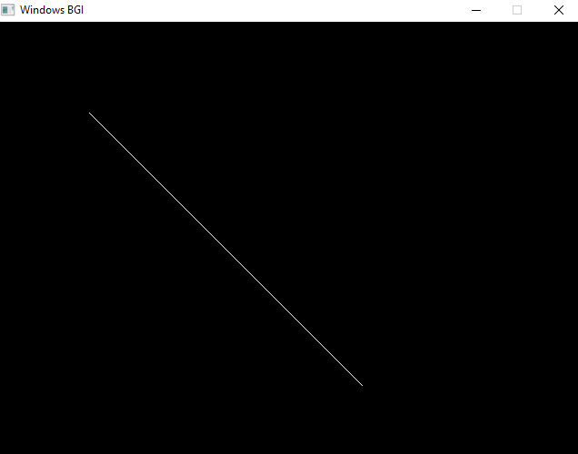
#include <graphics.h>
void bresenhamLine(int x1, int y1, int x2, int y2) {
int dx = abs(x1 - x2);int dy = abs(y1 - y2);
int p = 2 * dy - dx;int twoDy = 2 * dy;
int twoDyDx = 2 * (dy - dx);
int x, y,xend;
if (x1 > x2) {
x = x2;y = y2;
xend = x1;
} else {
x = x1;y = y1;
xend = x2;}
putpixel(x, y, WHITE);
while (x < xend) {
x++;
if (p < 0) p += twoDy;
else {
y++;
p += twoDyDx;}
putpixel(x, y, WHITE);
delay(2);
}}
int main() {
int gd = DETECT, gm;
initgraph(&gd, &gm, (char*)"Bresenham's Line Drawing Algorithm");
int x1 = 100, y1 = 100, x2 = 400, y2 = 400;
bresenhamLine(x1, y1, x2, y2);
getch();closegraph();
return 0;}
Output:
2. Write a program to implement mid-point circle drawing algorithm.
Code:
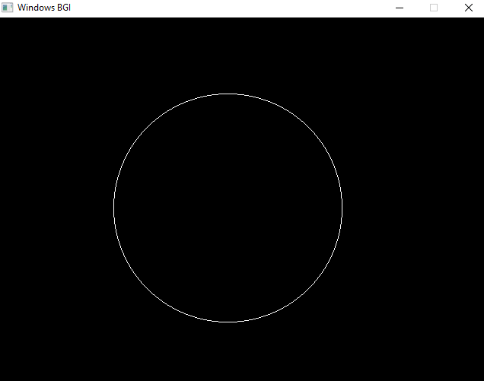
#include <graphics.h>
void circleplotPoints(int xc,int yc,int x,int y){
putpixel(xc + x, yc + y, WHITE);
putpixel(xc - x, yc + y, WHITE);
putpixel(xc + x, yc - y, WHITE);
putpixel(xc - x, yc - y, WHITE);
putpixel(xc + y, yc + x, WHITE);
putpixel(xc - y, yc + x, WHITE);
putpixel(xc + y, yc - x, WHITE);
putpixel(xc - y, yc - x, WHITE);}
void midpointCircle(int xc, int yc, int r) {
int x = 0, y = r;int p = 1 - r;
circleplotPoints(xc,yc,x,y);
while (x <= y) {
x++;
if (p < 0) {
p += 2 * x + 1;
} else {
y--;
p += 2 * (x - y) + 1;}
circleplotPoints(xc,yc,x,y);
delay(4);}}
int main() {
int gd = DETECT, gm;
initgraph(&gd, &gm, (char*)"");
int xc = 300, yc = 250, radius = 150;
midpointCircle(xc, yc, radius);
getch();closegraph();
return 0;}
Output:
3. Write a program to clip a line using Cohen and Sutherland line clipping algorithm.
Code:
#include <iostream>
#include <graphics.h>
using namespace std;
const int INSIDE = 0; const int LEFT = 1;
const int RIGHT = 2; const int BOTTOM = 4;
const int TOP = 8;
int computeRegionCode(double x, double y, double x_min, double x_max, double y_min, double y_max) {
int code = INSIDE;
if (x < x_min) code |= LEFT;
else if (x > x_max) code |= RIGHT;
if (y < y_min) code |= BOTTOM;
else if (y > y_max) code |= TOP;
return code;}
void cohenSutherlandClip(double x0, double y0, double x1, double y1, double x_min, double x_max, double y_min, double y_max) {
int gd = DETECT, gm;
initgraph(&gd, &gm, NULL);
rectangle(x_min, y_min, x_max, y_max);
setcolor(RED);
line(x0, y0, x1, y1);
int code0 = computeRegionCode(x0, y0, x_min, x_max, y_min, y_max);
int code1 = computeRegionCode(x1, y1, x_min, x_max, y_min, y_max);
bool accept = false;
while (true) {
if ((code0 == 0) && (code1 == 0)) {
accept = true; break;
} else if (code0 & code1) {break;
} else {double x, y;
int outcode = (code0 != 0) ? code0 : code1;
if (outcode & TOP) {
x = x0 + (x1 - x0) * (y_max - y0) / (y1 - y0);
y = y_max;
} else if (outcode & BOTTOM) {
x = x0 + (x1 - x0) * (y_min - y0) / (y1 - y0);
y = y_min;
} else if (outcode & RIGHT) {
y = y0 + (y1 - y0) * (x_max - x0) / (x1 - x0);
x = x_max;
} else if (outcode & LEFT) {
y = y0 + (y1 - y0) * (x_min - x0) / (x1 - x0);
x = x_min;}
if (outcode == code0) {
x0 = x; y0 = y;
code0 = computeRegionCode(x0, y0, x_min, x_max, y_min, y_max);
} else {
x1 = x; y1 = y;
code1 = computeRegionCode(x1, y1, x_min, x_max, y_min, y_max);}}}
if (accept) {
setcolor(GREEN);
line(x0, y0, x1, y1);
cout << "Line accepted from (" << x0 << ", " << y0 << ") to (" << x1 << ", " << y1 << ")" << endl;
} else {
cout << "Line rejected" << endl;}
getch(); closegraph(); }
int main() {
double x_min = 150.0, y_min = 150.0, x_max = 350.0, y_max = 350.0;
double x0 = 100.0, y0 = 200.0, x1 = 400.0, y1 = 300.0;
cohenSutherlandClip(x0, y0, x1, y1, x_min, x_max, y_min, y_max);
return 0;}
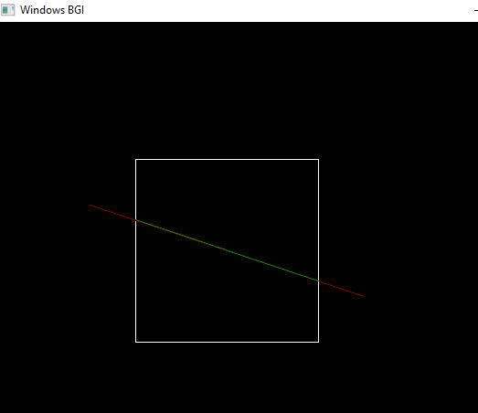
Output:

4. Write a program to clip a polygon using Sutherland Hodgeman algorithm.
Code:
#include <graphics.h>
#include <vector>
#include <iostream>
struct Point {
int x, y;};
bool isInside(Point p, Point clipEdgeStart, Point clipEdgeEnd) {
return (clipEdgeEnd.x - clipEdgeStart.x) * (p.y - clipEdgeStart.y) -
(clipEdgeEnd.y - clipEdgeStart.y) * (p.x - clipEdgeStart.x) >= 0;}
Point getIntersection(Point s, Point e, Point clipEdgeStart, Point clipEdgeEnd) {
int x1 = s.x, y1 = s.y; int x2 = e.x, y2 = e.y;
int x3 = clipEdgeStart.x, y3 = clipEdgeStart.y;
int x4 = clipEdgeEnd.x, y4 = clipEdgeEnd.y;
int denom = (x1 - x2) * (y3 - y4) - (y1 - y2) * (x3 - x4);
int intersectX = ((x1 * y2 - y1 * x2) * (x3 - x4) - (x1 - x2) * (x3 * y4 - y3 * x4)) / denom;
int intersectY = ((x1 * y2 - y1 * x2) * (y3 - y4) - (y1 - y2) * (x3 * y4 - y3 * x4)) / denom;
return { intersectX, intersectY };}
std::vector<Point> sutherlandHodgmanClip(std::vector<Point>& polygon, std::vector<Point>& clipWindow) {
std::vector<Point> clippedPolygon = polygon;
for (size_t i = 0; i < clipWindow.size(); i++) {
std::vector<Point> newPolygon;
Point clipEdgeStart = clipWindow[i];
Point clipEdgeEnd = clipWindow[(i + 1) % clipWindow.size()];
for (size_t j = 0; j < clippedPolygon.size(); j++) {
Point current = clippedPolygon[j];
Point prev = clippedPolygon[(j + clippedPolygon.size() - 1) % clippedPolygon.size()];
bool currInside = isInside(current, clipEdgeStart, clipEdgeEnd);
bool prevInside = isInside(prev, clipEdgeStart, clipEdgeEnd);
if (currInside) {
if (!prevInside)
newPolygon.push_back(getIntersection(prev, current, clipEdgeStart, clipEdgeEnd));
newPolygon.push_back(current);
} else if (prevInside) {
newPolygon.push_back(getIntersection(prev, current, clipEdgeStart, clipEdgeEnd));}}
clippedPolygon = newPolygon;}
return clippedPolygon;}
void drawPolygon(const std::vector<Point>& polygon, int color) {
setcolor(color);
int n = polygon.size();
for (int i = 0; i < n; i++) { delay(50);
line(polygon[i].x, polygon[i].y, polygon[(i + 1) % n].x, polygon[(i + 1) % n].y);
delay(50);}}
int main() {
int gd = DETECT, gm; initgraph(&gd, &gm,NULL);
std::vector<Point> polygon = {{100, 150}, {200, 250}, {300, 200}, {250, 100}, {150, 50}};
std::vector<Point> clipWindow = {{100, 100}, {300, 100}, {300, 300}, {100, 300}};
std::vector<Point> clippedPolygon = sutherlandHodgmanClip(polygon, clipWindow);
drawPolygon(polygon, RED);
delay(900); drawPolygon(clipWindow, WHITE);
delay(900); drawPolygon(clippedPolygon, GREEN);
getch(); closegraph();
return 0; }
Output:
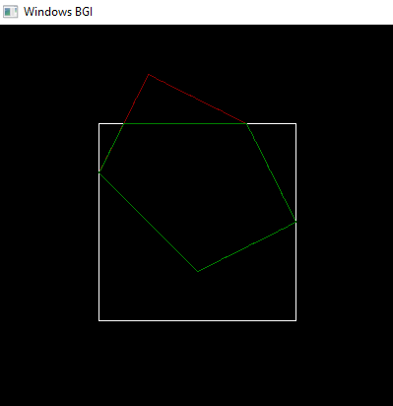

5. Write a program to fill a polygon using Scan line fill algorithm.
Code:
#include <graphics.h>
#include <iostream>
#include <vector>
#include <algorithm>
using namespace std;
struct Point {
int x, y;};
void scanLineFill(vector<Point> polygon) {
int n = polygon.size();
int ymin = INT_MAX, ymax = INT_MIN;
for (int i = 0; i < n; i++) {
delay(1);
ymin = min(ymin, polygon[i].y);
ymax = max(ymax, polygon[i].y);}
for (int y = ymin; y <= ymax; y++) {
vector<int> intersections;
for (int i = 0; i < n; i++) {
delay(1);
Point p1 = polygon[i];
Point p2 = polygon[(i + 1) % n];
if (p1.y == p2.y) continue;
if (y > min(p1.y, p2.y) && y <= max(p1.y, p2.y)) {
int x = p1.x + (y - p1.y) * (p2.x - p1.x) / (p2.y - p1.y);
intersections.push_back(x);}}
sort(intersections.begin(), intersections.end());
for (int i = 0; i < intersections.size(); i += 2) {
delay(1);
line(intersections[i], y, intersections[i + 1], y);}}}
int main() {
int gd = DETECT, gm;
initgraph(&gd, &gm, (char*)"");
vector<Point> polygon = {{200, 100}, {300, 200}, {250, 350}, {150, 350}, {100, 200}}; //A Pentagen
vector<Point> rect = {{300, 300}, {450, 300}, {450, 450}, {300, 450}}; //A quadrilateral
for (int i = 0; i < polygon.size(); i++) {
Point p1 = polygon[i];
Point p2 = polygon[(i + 1) % polygon.size()];
line(p1.x, p1.y, p2.x, p2.y);}
for (int i = 0; i < rect.size(); i++) {
Point p1 = rect[i];
Point p2 = rect[(i + 1) % rect.size()];
line(p1.x, p1.y, p2.x, p2.y);}
scanLineFill(polygon);
scanLineFill(rect);
getch();closegraph();
return 0;}
Output:
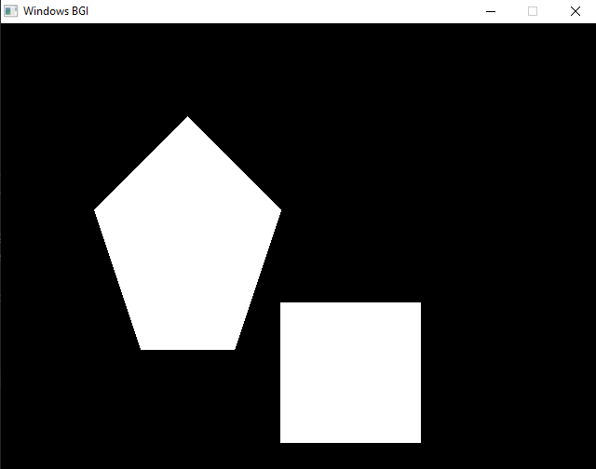
6. Write a program to apply various 2D transformations on a 2D object .
Code:
#include <graphics.h>
#include <iostream>
#include <cmath>
using namespace std;
struct Point {
int x, y, w; };
void translate(Point transformedshape[],int tx, int ty,int n) {
for (int i = 0; i < n; i++) {
transformedshape[i].x += tx;
transformedshape[i].y += ty; }}
void scale(Point originalshape[], Point transformedshape[], float sx, float sy,int n) {
for (int i = 0; i < n; i++) {
transformedshape[i].x = static_cast<int>(originalshape[i].x * sx);
transformedshape[i].y = static_cast<int>(originalshape[i].y * sy);}}
void rotate(Point originalshape[], Point transformedshape[], float angle,int n) {
for (int i = 0; i < n; i++) {
float rad = angle * M_PI / 180.0;
int x_new = static_cast<int>(originalshape[i].x * cos(rad) - originalshape[i].y * sin(rad));
int y_new = static_cast<int>(originalshape[i].x * sin(rad) + originalshape[i].y * cos(rad));
transformedshape[i].x = x_new;
transformedshape[i].y = y_new;}}
void drawShape(Point shape[], int n) {
for (int i = 0; i < n; i++) {
delay(10);
line(shape[i].x, shape[i].y, shape[(i + 1) % n].x, shape[(i + 1) % n].y);
delay(10);}}
int main() {
int gd = DETECT, gm;
initgraph(&gd, &gm, (char*)"");
Point originalshape[] = {{50, 50, 1}, {150, 50, 1}, {150, 150, 1}, {50, 150, 1}}; // A quadrilateral
int n = sizeof(originalshape) / sizeof(originalshape[0]);
Point transformedshape[4];
copy(begin(originalshape), end(originalshape), begin(transformedshape));
int tx = 125, ty = 125; float sx = 1.5, sy = 1.5;
float angle = -25;
drawShape(originalshape, n);
translate(transformedshape,tx, ty,n);
setcolor(YELLOW);
drawShape(transformedshape, n);
getch(); cleardevice();
drawShape(originalshape, n);
rotate(transformedshape, transformedshape, angle, n);
setcolor(MAGENTA);
drawShape(transformedshape, n);
getch(); cleardevice();
drawShape(originalshape, n);
scale(originalshape, transformedshape, sx, sy,n);
setcolor(GREEN);
drawShape(transformedshape, n); getch();
closegraph();
return 0;}
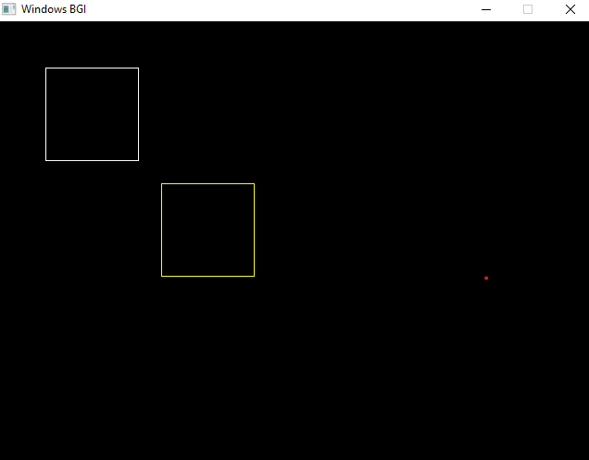
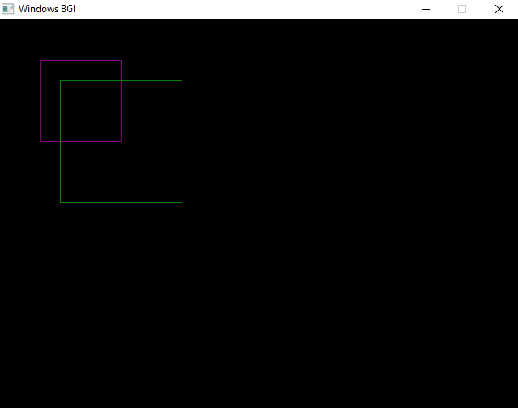
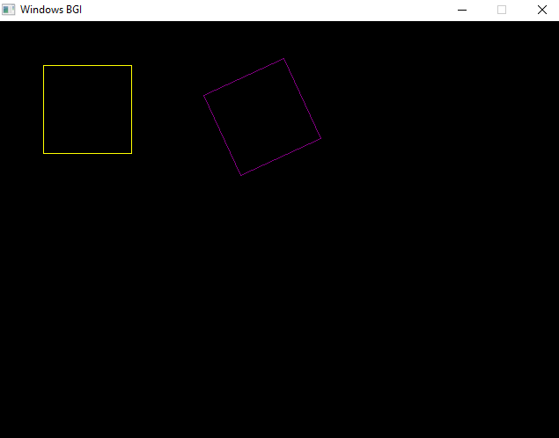
Output:
7. Write a program to apply various 3D transformations on a 3D object and then apply parallel and perspective projection on it.
Code:
#include <graphics.h>
#include <conio.h>
#include <iostream>
#include <cmath>
using namespace std;
struct Point3D {
int x, y, z; };
Point3D project(Point3D p, int d = 200) {
Point3D projected;
projected.x = p.x * d / (d + p.z);
projected.y = p.y * d / (d + p.z);
projected.z = p.z;
return projected;}
void drawCube(Point3D points[]) {
for (int i = 0; i < 4; i++) {
Point3D p1 = project(points[i]);
Point3D p2 = project(points[(i + 1) % 4]);
Point3D p3 = project(points[i + 4]);
Point3D p4 = project(points[(i + 1) % 4 + 4]);
line(p1.x, p1.y, p2.x, p2.y);
line(p3.x, p3.y, p4.x, p4.y);
line(p1.x, p1.y, p3.x, p3.y);}}
void translate(Point3D points[], Point3D original[], int tx, int ty, int tz) {
for (int i = 0; i < 8; i++) {
points[i].x = original[i].x + tx;
points[i].y = original[i].y + ty;
points[i].z = original[i].z + tz;}}
void scale(Point3D points[], Point3D original[], float sx, float sy, float sz) {
for (int i = 0; i < 8; i++) {
points[i].x = original[i].x * sx;
points[i].y = original[i].y * sy;
points[i].z = original[i].z * sz;}}
void rotateX(Point3D points[], Point3D original[], float angle) {
float rad = angle * M_PI / 180.0;
for (int i = 0; i < 8; i++) {
points[i].x = original[i].x;
points[i].y = original[i].y * cos(rad) - original[i].z * sin(rad);
points[i].z = original[i].y * sin(rad) + original[i].z * cos(rad);}}
int main() {
int gd = DETECT, gm;
initgraph(&gd, &gm,NULL);
Point3D originalCube[8] = {
{50, 50, 50}, {150, 50, 50}, {150, 150, 50}, {50, 150, 50},
{50, 50, -50}, {150, 50, -50}, {150, 150, -50}, {50, 150, -50}};
Point3D transformedCube[8];
copy(begin(originalCube), end(originalCube), begin(transformedCube));
drawCube(transformedCube);
setcolor(YELLOW); translate(transformedCube, originalCube, 50, 50, 0);
drawCube(transformedCube);
getch(); cleardevice();
drawCube(transformedCube);
setcolor(GREEN); scale(transformedCube, originalCube, 1.5, 1.5, 1.5);
drawCube(transformedCube);
getch(); cleardevice();
drawCube(transformedCube);
setcolor(CYAN); rotateX(transformedCube, originalCube, 45);
drawCube(transformedCube);
getch(); cleardevice();
closegraph(); return 0;}
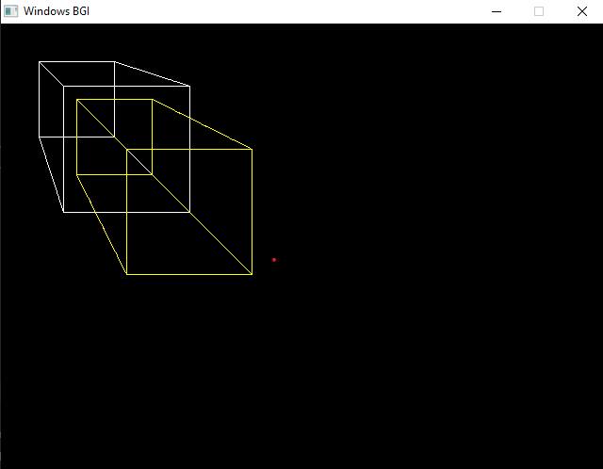
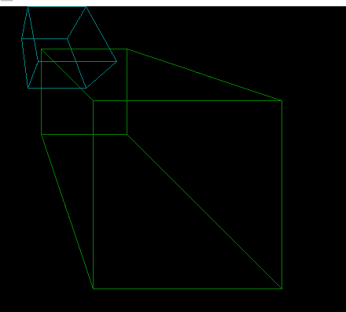
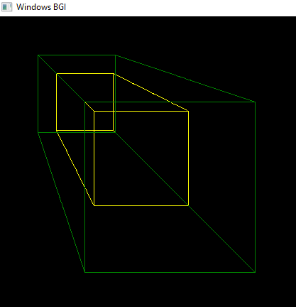
Output:
8 a). Write a program to draw Bezier curve.
Code:
#include <graphics.h>
#include <iostream>
#include <math.h>
using namespace std;
void drawBezierCurve(int x0, int y0, int x1, int y1, int x2, int y2, int x3, int y3) {
for (float t = 0; t <= 1; t += 0.001) {
delay(5);
float xt = pow(1 - t, 3) * x0 + 3 * t * pow(1 - t, 2) * x1 + 3 * pow(t, 2) * (1 - t) * x2 + pow(t, 3) * x3;
float yt = pow(1 - t, 3) * y0 + 3 * t * pow(1 - t, 2) * y1 + 3 * pow(t, 2) * (1 - t) * y2 + pow(t, 3) * y3;
putpixel(xt, yt, WHITE);}}
int main() {
int gd = DETECT, gm;
initgraph(&gd, &gm, (char*) "");
int x0 = 100, y0 = 400;
int x1 = 200, y1 = 100;
int x2 = 400, y2 = 100;
int x3 = 500, y3 = 400;
drawBezierCurve(x0, y0, x1, y1, x2, y2, x3, y3);
getch();closegraph();
return 0;}
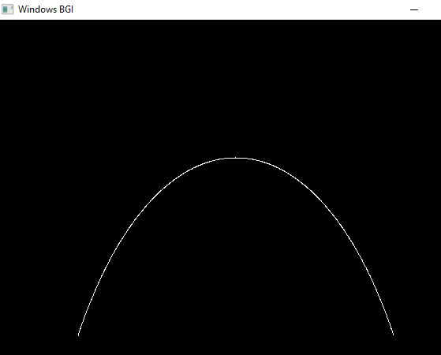
Output:

8 b). Write a program to draw Hermite curve.
Code:
#include <graphics.h>
#include <conio.h>
#include <iostream>
#include <math.h>
using namespace std;
void drawHermiteCurve(int x0, int y0, int x1, int y1, int rx0, int ry0, int rx1, int ry1) {
for (float t = 0.0; t <= 1.0; t += 0.001) {
delay(2);
float h1 = 2*t*t*t - 3*t*t + 1;
float h2 = -2*t*t*t + 3*t*t;
float h3 = t*t*t - 2*t*t + t;
float h4 = t*t*t - t*t;
int x = h1*x0 + h2*x1 + h3*rx0 + h4*rx1;
int y = h1*y0 + h2*y1 + h3*ry0 + h4*ry1;
putpixel(x, y, WHITE);}}
int main() {
int gd = DETECT, gm;
initgraph(&gd, &gm, (char*) "");
int x0 = 100, y0 = 400;
int x1 = 400, y1 = 100;
int rx0 = 150, ry0 = 200;
int rx1 = 100, ry1 = 200;
drawHermiteCurve(x0, y0, x1, y1, rx0, ry0, rx1, ry1);
getch();closegraph();return 0;
}
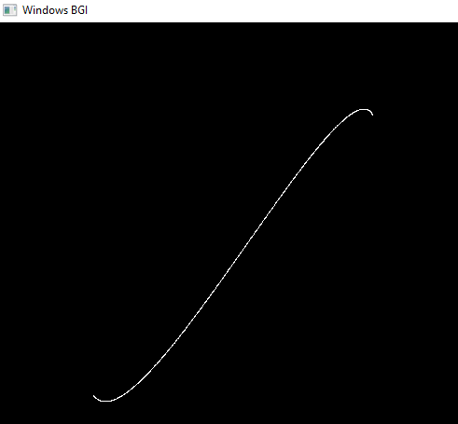
Output:

